# Windows Server 2012: Set Up your First Domain Controller

In Windows Server 2012, **dcpromo has been deprecated**.

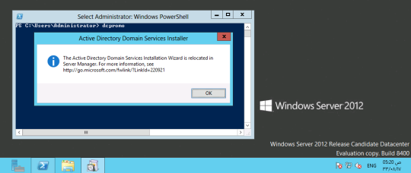

Using Server Manager (UI):

In order to make the windows server 2012 domain controller we will install ADDS (Active Directory Domain Services) role from the server manager on Windows Server 2012.

All the Latest security updates must applied before installing the Role.

First we will change the server name let say **DC01**and the IP address 10.10.21.1 (try to avoid using default 192.168.0.1)

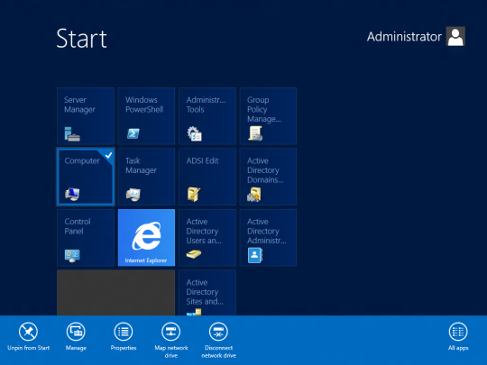

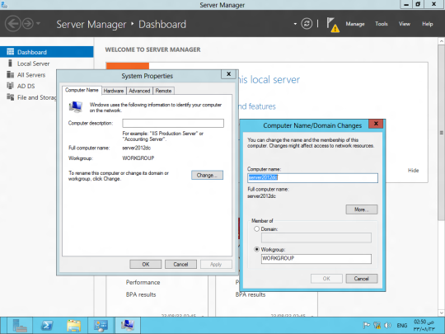

Installing the AD DS role

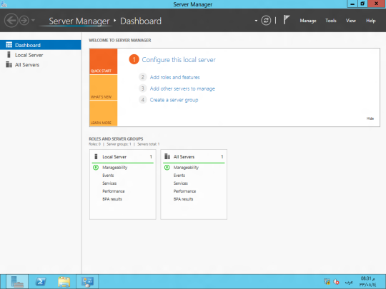

“Before You Begin” screen provides you basic information such as configuring strong passwords, IP addresses and Windows updates.

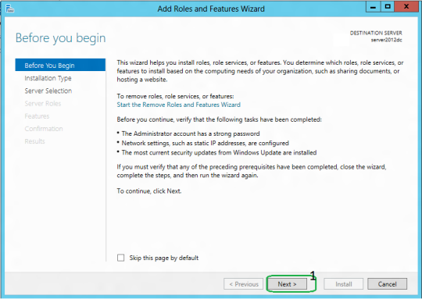

On **Installation Type** page, select the first option “**Role-based or Feature-based Installation**“.

Scenario-based Installation option applied only to Remote Desktop services.

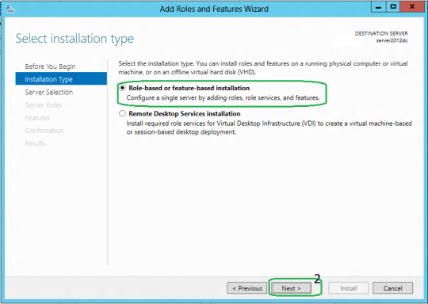

On the “Server Selection” Page, **select a server from the server pool**and click next.

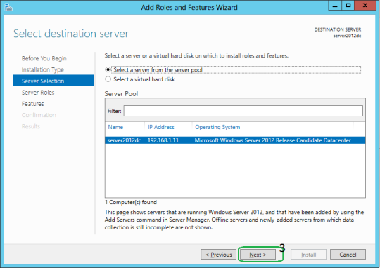

To install AD DS, select **Active Directory Domain Services** in turn it will pop-up to add other AD DS related tools. Click on **Add Features**.

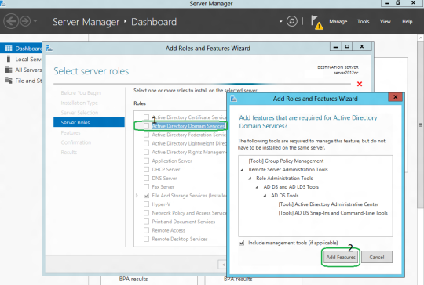

After clicking “Add Features” above, you will be able to click “Next >” as shown in the screen below.

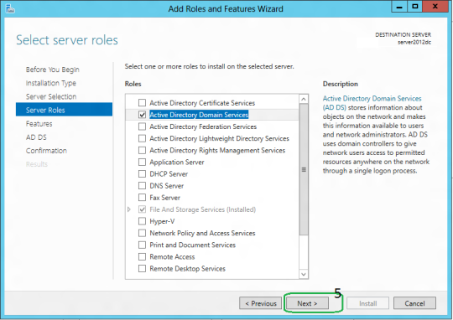

On the “**Select Features**” Page, **Group Policy Management feature**automatically installed during the promotion. Click next.

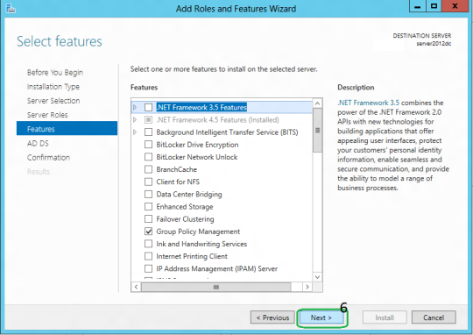

On the “Active Directory Domain Services” page, it gives basic information about AD DS. Click Next.

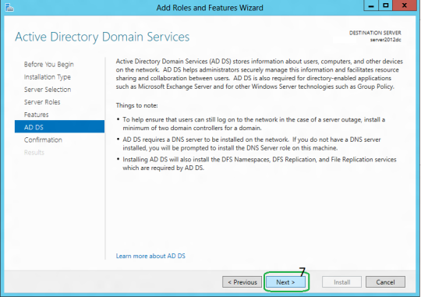

On the “Confirmation” Page, You need to confirm this to continue with this configuration. It will provide you an option to export the configuration settings and also if you want the server to be restarted automatically as required.

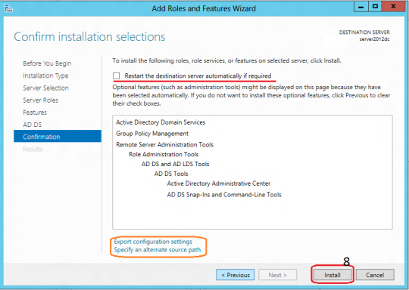

After clicking “**Install**” the selected role binaries will be installed on the server.

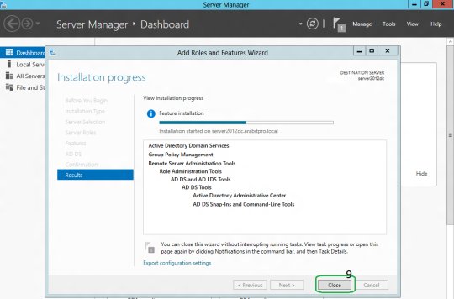

After “Active Directory Domain Services” role binaries have been installed and now it is time to promote the server to a Domain Controller.

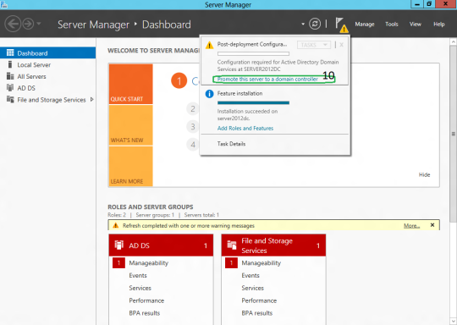

**TechNet Article:**

* [Install Active Directory Domain Services](http://technet.microsoft.com/en-us/library/hh472162)**.**

PROMOTING WINDOWS 2012 SERVER TO DOMAIN CONTROLLER

To create a new AD forest called “ArabITPro.local”, select add a new forest.

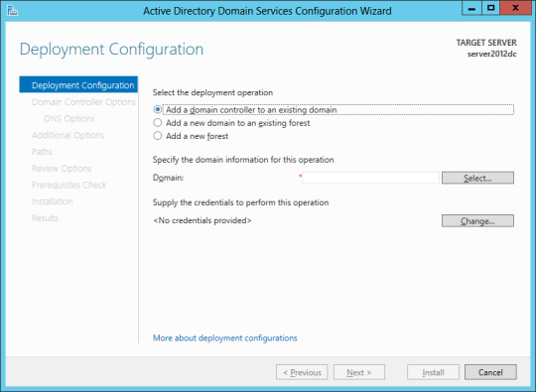

Type the name ArabITPro.local

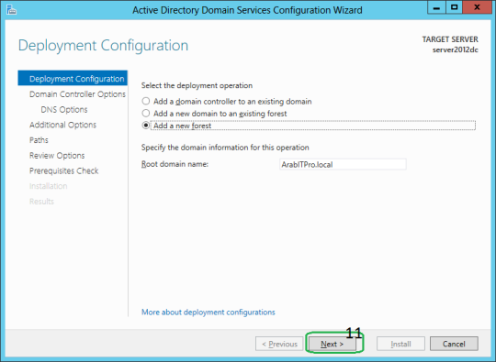

Specify the FFL, DFL, whether or not it should be a DNS Server and also the DSRM administrator password. As you can see, it has selected the GC option by default and you cannot deselect it. The reason for this is that is the very first DC of the AD forest and at least one needs to be a GC.

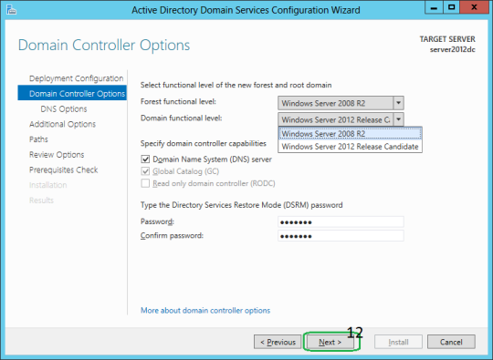

DNS delegation warning.

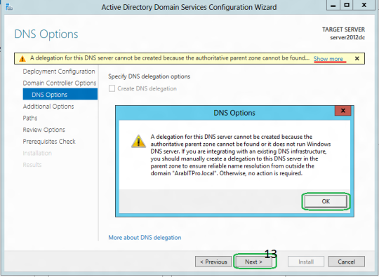

Checks the NetBIOS name already assigned.

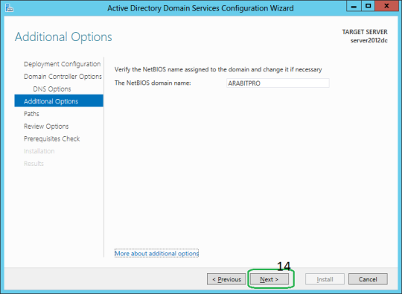

Specify the location of the AD related folders and then click next.

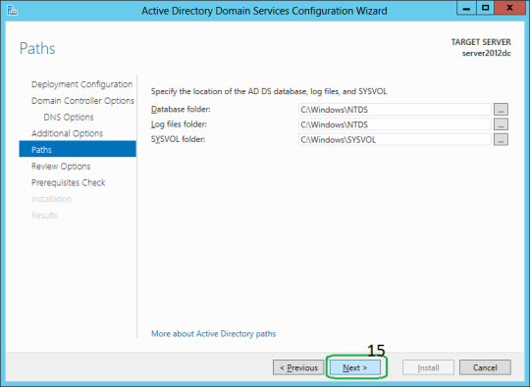

Summary Of All Installation Options/Selections.

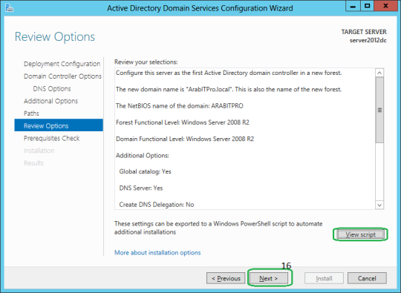

Click View script for single command line PowerShell script for dcpromo.

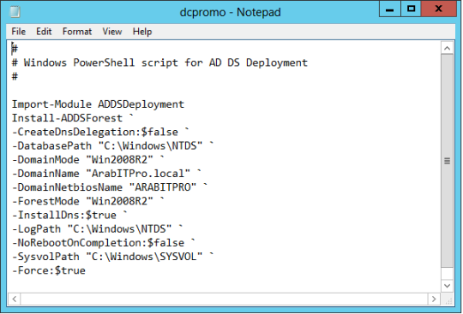

Before the actual install of AD, all prerequisites are checked. If All prerequisite checks are passed successfully then click**Install.**

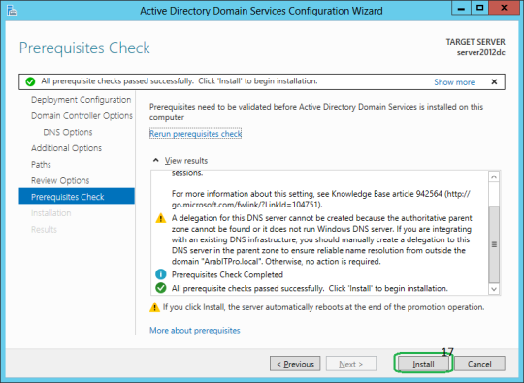

When you click Install, DNS and the GPMC are installed automatically.

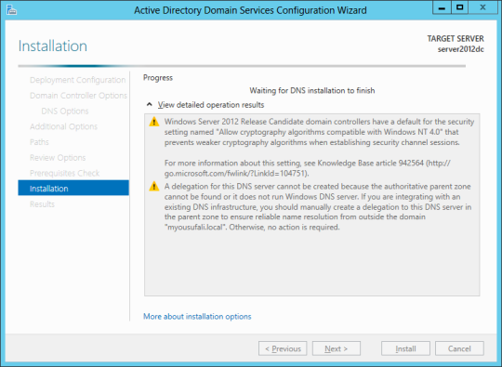

After the promotion of the server to a DC finished server restart automatically.

Once the server is booted and you logon to it, click on Server Manager | Tools , will notice that following have been installed:

* Active Directory Administrative Center
* Active Directory Domains and Trusts
* Active Directory Module for Windows PowerShell
* Active Directory Sites and Services
* Active Directory Users and Computers
* ADSI Edit
* DNS
* Group Policy Management

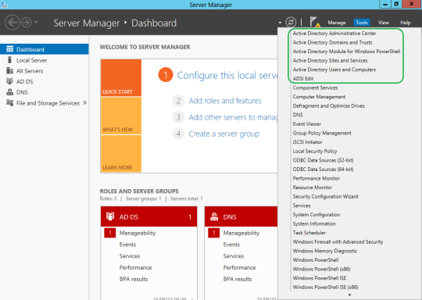

TODO: Next step is to install the replica domain controller for high availability.